**APPENDIX A**

Letter of Invitation for Thesis Adviser

**NOTRE DAME OF TACURONG COLLEGE**  
City of Tacurong

July 27, 2017

**JEZRELL L. FULGENCIO**  
Notre Dame of Tacurong College

Dear Sir,

Part of BS in Computer Science curriculum is to accomplish at least one (1) Thesis Study with Software implementation for one whole year. The said study will help the students show their potentials in research writing and create an innovative software program that will contribute much to the development of BSCS department and its curriculum.

Currently, the researcher is creating a system called JoRex: An Artificial Intelligence (AI) Motion-Based Fruit Razor Computer Game.

In this regard, may the researchers ask you to be their Adviser/Consultant for the above-mentioned study. The researchers believe that your expertise can be of great help throughout the researchers’ research work.

Thank you very much for your favorable merit to this request.

Truly yours,

**(SGD.) JOBERT L. DELLAVA  
(SGD.) REX LOUIS P. RONCESVALLES**  
Researchers

Noted by:

**(SGD.) ANALIZA S. HENODIA, MIT (SGD.)ENGR. KATHRYN N. PURAZO,MSIT**  
BSCS Thesis Instructress Program Head, BSCS/BSCpE

Approved by:  
 **(SGD.) JEZRELL L. FULGENCIO**  
Thesis Advise

**APPENDIX B**

Letter of Invitation for Thesis Reader

**NOTRE DAME OF TACURONG COLLEGE**  
City of Tacurong

July 27, 2017

**MELEHENDE C. AGUACITO**  
Notre Dame of Tacurong College

Dear Sir,

Part of BS in Computer Science curriculum is to accomplish at least one (1) Thesis Study with Software implementation for one whole year. The said study will help the students show their potentials in research writing and create an innovative software program that will contribute much to the development of BSCS department and its curriculum.

Currently, the researcher is creating a system called JoRex: An Artificial Intelligence (AI) Motion-Based Fruit Razor Computer Game.

In this regard, may the researchers ask you to be their Reader for the above-mentioned study. The researchers believe that your expertise can be of great help throughout the researchers’ research work.Thank you very much for your favorable merit to this request.

Truly yours,

**(SGD.) JOBERT L. DELLAVA**

**(SGD.) REX LOUIS P. RONCESVALLES**  
  
Researchers

Noted by:

**(SGD.)ANALIZA S. HENODIA, MIT (SGD.)ENGR. KATHRYN N. PURAZO,MSIT**  
BSCS Thesis Instructress Program Head, BSCS/BSCpE

Approved by:

**(SGD.)** **MELEHENDE C. AGUACITO**  
Thesis Grammarian

**APPENDIX C**

Application Letter for Title Proposal Defense

**NOTRE DAME OF TACURONG COLLEGE  
City of Tacurong**

July 24, 2018

**ANALIZA S. HENODIA, MIT**Thesis Writing Instructress

Dear Madam:

Greetings!

The group has already reviewed and presented the **Research Proposal Application Guides** in your office last June 26, 2017. Hence, we decided to present the research studies we have submitted in the panel which are entitled “Object Recognition Application for visually impaired person and preschooler” and “Jorex: An Artificial Intelligence (AI) Motion-based Fruit Razor Computer Game”.

In this regard, we are applying for the incoming **Thesis Proposal Application Defense** on **July 21, 2017**. We are looking forward to see our group’s name in the above defense’s schedule.

Thank you very much for your anticipation to this matter.

Truly yours,

**(SGD.) JOBERT L. DELLAVA  
  
(SGD.) REX LOUIS P. RONCESVALLES  
  
Researchers**

Approved by:  
 **(SGD.)ANALIZA S. HENODIA, MIT**  
Thesis Writing Instructress

**APPENDIX D**

Application Letter for Chapter Defense

**NOTRE DAME OF TACURONG COLLEGE  
City of Tacurong**

October 11, 2017

**ANALIZA S. HENODIA, MIT**Subject Instructress

Dear Madam:

Greetings!

The group has already accomplished the three Chapters of the research study and its 50-75% program output. Hence, to know the reliability and accuracy of our paper and software program, please allow us to present them on October 13, 2017 at exactly 9:00 am in the EC laboratory.

Our research study is “JoRex: An Artificial Intelligence (AI) Motion-Based Fruit Razor Computer Game”.

We hope that with your approval we will be able to show the contents of our Thesis study. Attached herewith is the letter of appointment for our panelists on the said date.

Thank you very much.  
Truly yours,

**(SGD.) JOBERT L. DELLAVA**

**(SGD.) REX LOUIS P. RONCESVALLES**Researchers

Approved by:

**(SGD.)ANALIZA S. HENODIA, MIT**Subject Instructress

**APPENDIX E**

Application Letter for Software Defense

**NOTRE DAME OF TACURONG COLLEGE  
City of Tacurong**

February 26, 2018

**ANALIZA S. HENODIA, MIT**Thesis Writing Instructress

Dear Madam:

Greetings!

The group has already accomplished the four Chapters of the research study and its 100% program output. Hence, to know the reliability and accuracy of our paper and software program, please allow us to present to the panelist the said 100% program output on February 28, 2018 at exactly 9:00 am in the EC laboratory.

Our research study is entitled “JoRex: An Artificial Intelligence (AI) Motion-Based Fruit Razor Computer Game”. We hope that with your approval we will be able to show the contents of our Thesis study. Attached herewith is the letter of appointment for our panelists on the said date.

Thank you very much.

Truly yours,

**(SGD.) JOBERT L. DELLAVA   
(SGD.) REX LOUIS P. RONCESVALLES**Researchers

Approved by:

**(SGD.)ANALIZA S. HENODIA, MIT**Subject Instructress

**APPENDIX F**

Application Letter for Final Defense

**NOTRE DAME OF TACURONG COLLEGE  
City of Tacurong**

March 12, 2018

**ANALIZA S. HENODIA, MIT**BSCS Thesis Instructress

Dear Madam:

Greetings!

The group is happy to inform you that we had already accomplished one greatest achievement in Academic life –our Thesis study which is entitled “JoRex: An Artificial Intelligence (AI) Motion-Based Fruit Razor Computer Game”.

In this connection, we would like to apply for a **Final Defense** this coming March 13, 2018, at exactly 9:00, at EC laboratory.

With your approval, we will be able to show the results and contributions of the said study to the community it covers.

Thank you very much.

Truly yours,

**(SGD.) JOBERT L. DELLAVA  
  
(SGD.) REX LOUIS P. RONCESVALLES**  
Researchers

Approved by:

**(SGD.)ANALIZA S. HENODIA, MIT**BSCS Thesis Instructress

**APPENDIX G**

**USERS’S MANUAL**

This section discusses the User’s Manual for the player to be guided on how to play the Jorex: An Artificial Intelligence (AI) Motion-Based Fruit Razor Computer Game.

In the Main Menu the player can select PLAY, SCORE, HELP and ABOUT game using the sword by hitting the label button or to EXIT the game.

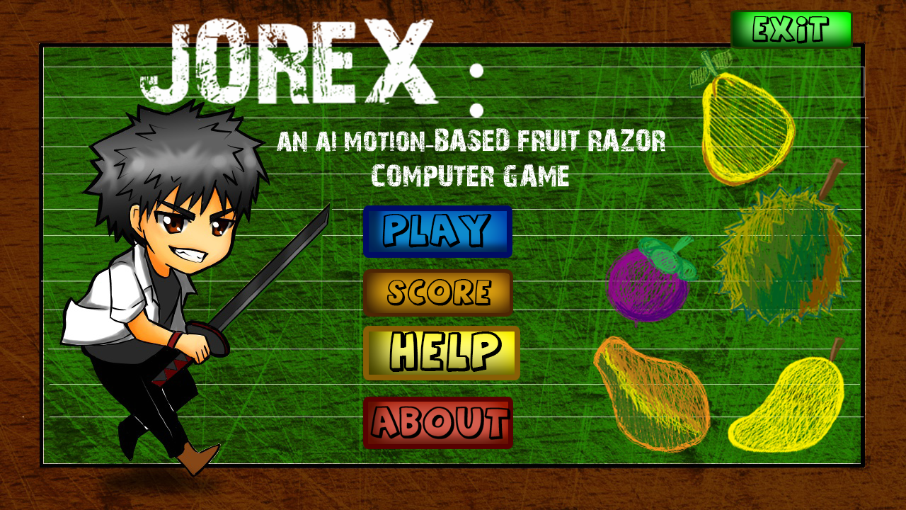

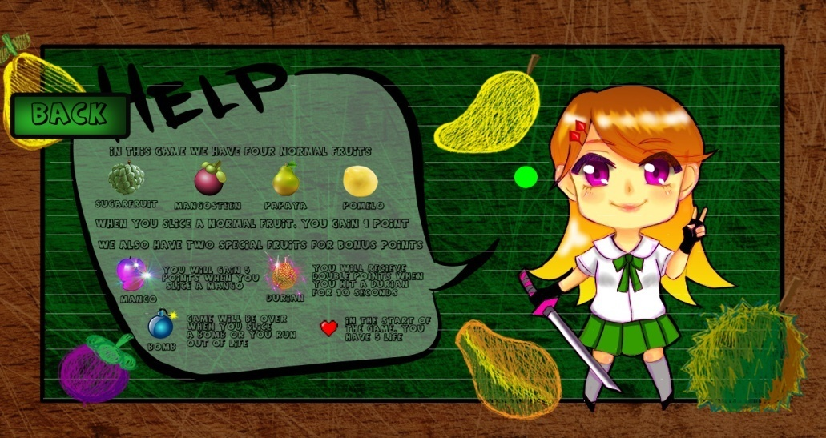

When the HELP button has been executed, it shows the different objects and its functions or either go back to Main menu.

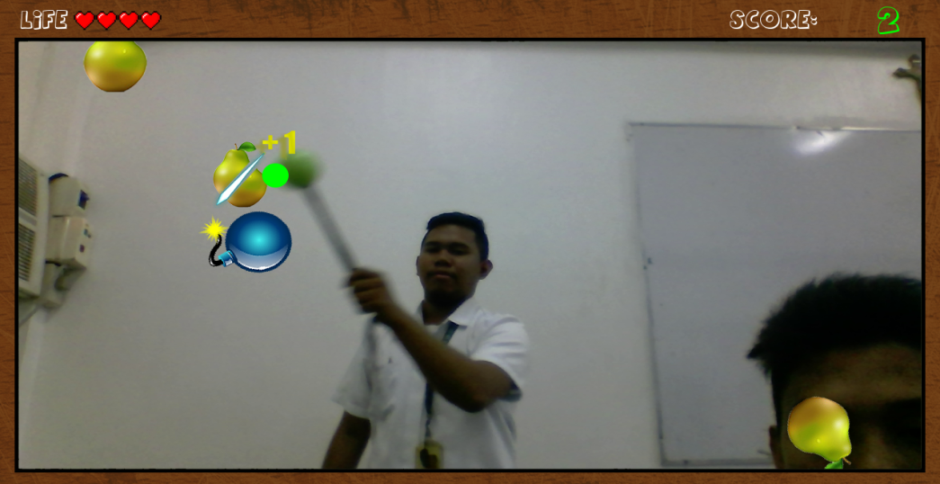

When the player hits the PLAY button in the game menu, the game automatically start.

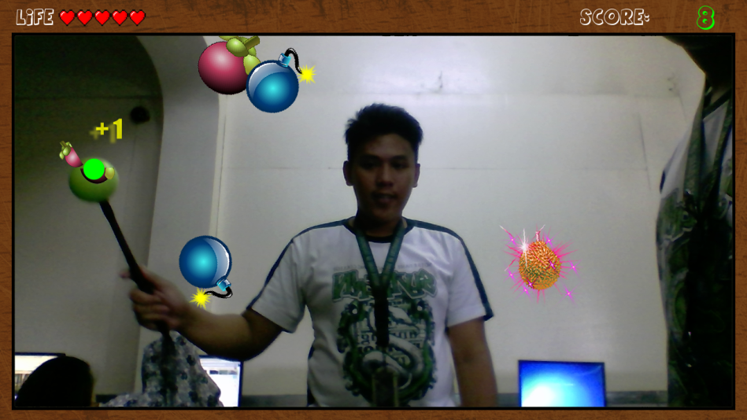

When the player sliced the normal fruits such as mangosteen, papaya, sugar fruit and pomelo it gives the corresponding one point.

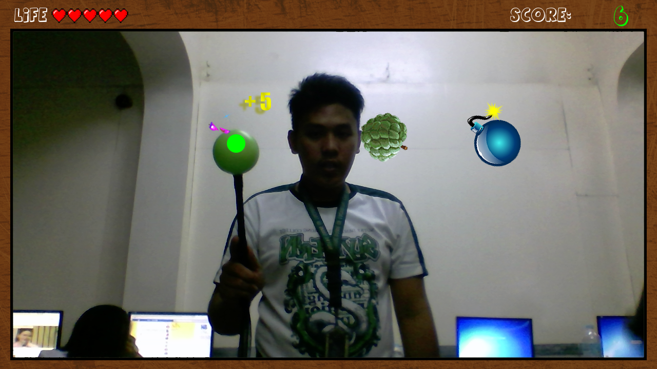

The game had features that could give special fruits such as mango and durian their corresponding points. When the player sliced the mango fruits, it gives the corresponding five points.

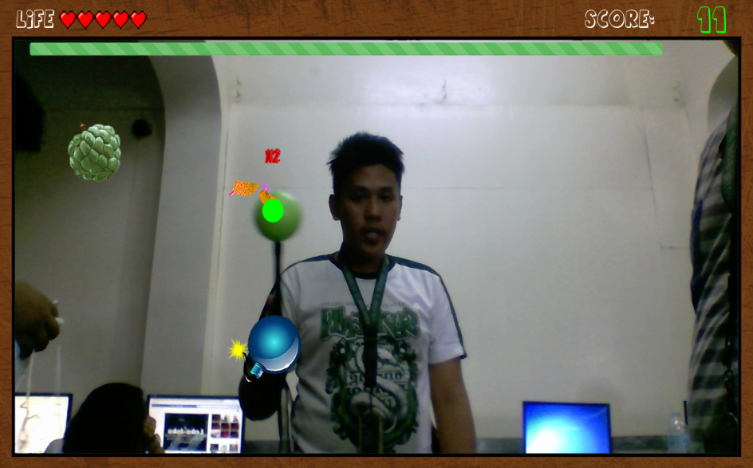

When the player sliced the durian fruits, all the fruits that the player sliced should be multiplied into two within ten seconds. So the normal fruits converted into two points and the mango fruits converted into ten points.

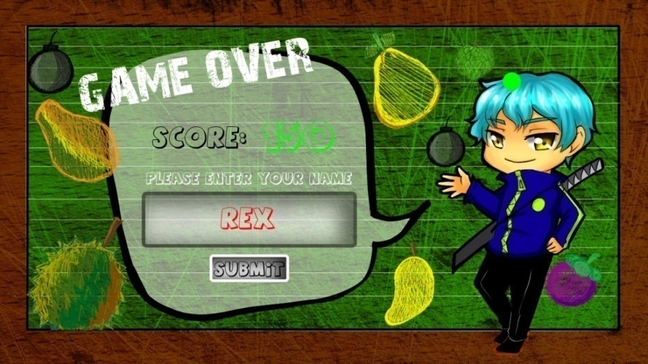

When the player sliced the bomb the game should be end. The player’s score will be displayed, requiring the game to input the player’s name in order to submit the details of the players.

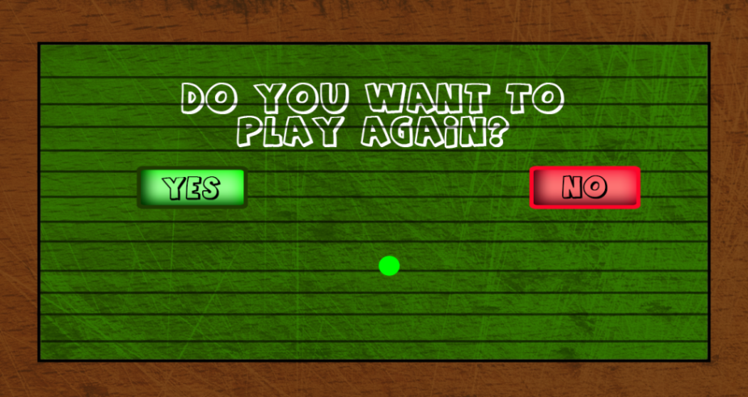

When the player hits the SUBMIT button, the game will proceed to another page that will ask the player “Do you want to play again?”. If the player hits the “Yes” button, he will go back to the main menu. If the player hits the “No” button, he will go back to the Menu page of the game.

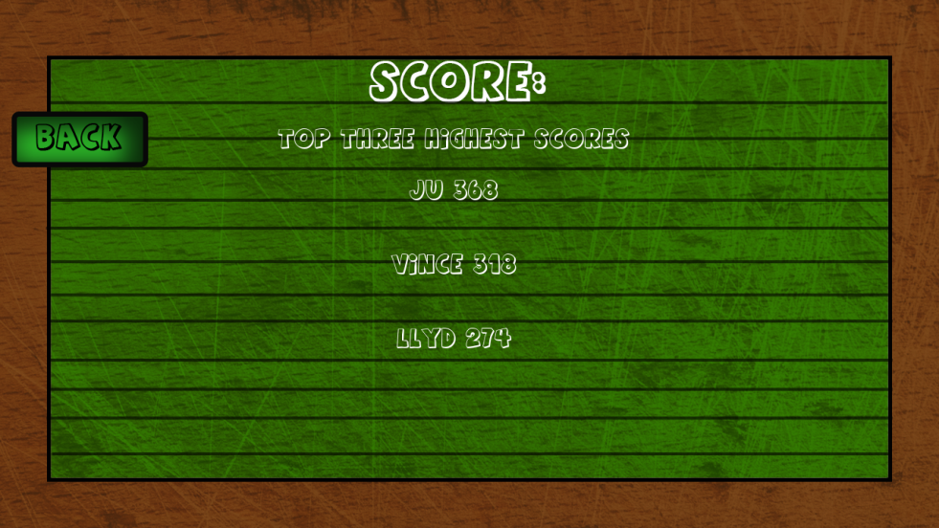

When the player hits the Score button the game proceed into another page that will display the top three highest scores of the game or hit the Back button to go back into the Menu page.

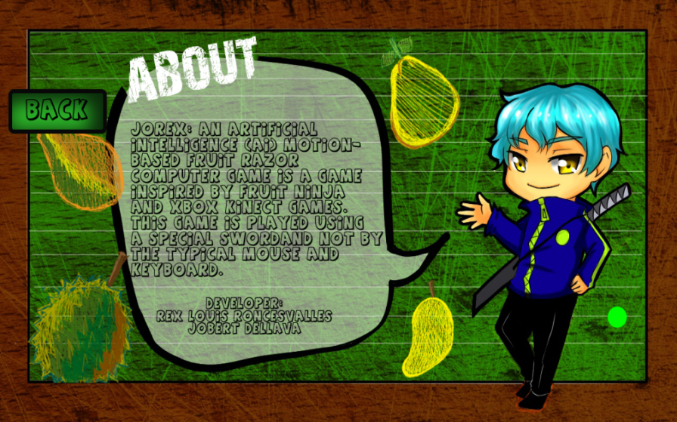

When the player hits the ABOUT button the game will proceed into another page that will display the brief introduction of the game and its developer. Then he hits the Back button to go back into the Menu page.

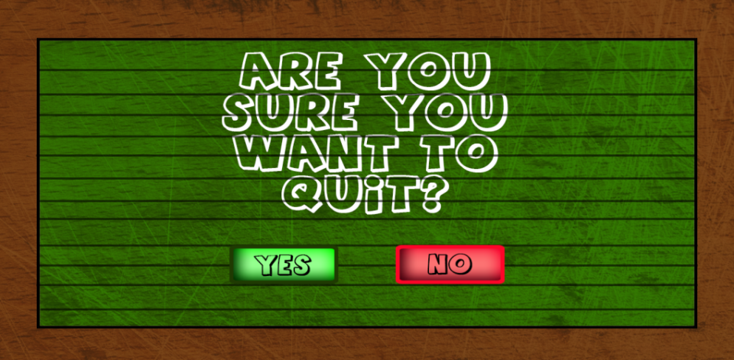

When the player hits the EXIT button in the menu page, the game will display another page that shows and asks the player if he wanted to quit the game. If the player hits the “Yes” button, the game will be terminated, and if the player hits the “No” button the game will go back to Menu page.

**APPENDIX H**

**NOTRE DAME OF TACURONG COLLEGE**

**City of Tacurong**

**JOREX: AN ARTIFICIAL INTELLIGENCE (AI) MOTION-BASED FRUIT RAZOR COMPUTER GAME**

**SURVEY QUESTIONNAIRE**

The purpose of this study is to collect informations that will evaluate and determine the respondents’ satisfaction on the proposed study, Jorex: An Artificial Intelligence (AI) Motion-Based Fruit Razor Computer Game.

Name:_______________________ Course**/**Year:__________ Department: _____

**Survey Instruction:** Please rate the following items honestly using the following scale by **checking** the box that corresponds to the result of your observation.

**4 – Strongly Agree 3 – Agree 2 – Disagree 1 – Strongly Disagree**

1. **Accuracy**

|  |  |  |  |  |
| --- | --- | --- | --- | --- |
| **Items** | **4** | **3** | **2** | **1** |
| 1.The developed system accurately cuts the following objects: | | | | |
| a. Fruits | | | | |
| a.1 durian |  |  |  |  |
| a.2 mango |  |  |  |  |
| a.3 mangosteen |  |  |  |  |
| a.4 papaya |  |  |  |  |
| a.5 pomelo |  |  |  |  |
| a.6 sugar fruit |  |  |  |  |
| b.Bombs |  |  |  |  |
| 2. The developed system accurately adds the corresponding points of the following objects when cut: | | | | |
| a. Fruits |  |  |  |  |
| a.1 durian |  |  |  |  |
| a.2 mango |  |  |  |  |
| a.3 mangosteen |  |  |  |  |
| a.4 papaya |  |  |  |  |
| a.5 pomelo |  |  |  |  |
| a.6 sugar fruit |  |  |  |  |
| 3. The developed system gives bonus points on the following special fruits when cut: | | | | |
| a. Durian (points multiplier for 10 seconds) |  |  |  |  |
| b. Mango (5 points) |  |  |  |  |
| 4. The developed system easily detects the coordinates of sword’s location. |  |  |  |  |
| 5. The developed system generates an accurate total score at the end of the game. |  |  |  |  |
| 6. The developed system ends the game when the player cuts the bomb. |  |  |  |  |

1. **User – Friendliness**

|  |  |  |  |  |
| --- | --- | --- | --- | --- |
| **Items** | **4** | **3** | **2** | **1** |
| 1. The developed system has distinct features for each fruits**/**objects. |  |  |  |  |
| 1. The developed system has clear instructions on the following menus: | | | | |
| 1. About |  |  |  |  |
| 1. Help |  |  |  |  |
| 1. Score |  |  |  |  |
| 1. The developed system can be easily manipulated by the player using the sword. |  |  |  |  |
| 1. The developed system has a good graphical user interface. |  |  |  |  |

Suggestions:

__________________________________________________________________________________________________________________________________________________________________________________________________________________________________________________________________________________________________________________________________________

*Thank you!*

**APPENDIX I**

**Proponent’s Profile**



**REX LOUIS P. RONCESVALLES**

**Purok Poblacion, 44 Ledesma St., Tacurong City**

**Sultan Kudarat**

**0975-436-3944**

**PERSONAL INFORMATION**

**Date of Birth: September 23, 1997**

**Age: 20 years old**

**Place of Birth: Valdez Hospital, Tacurong City**

**Nationality: Filipino**

**Gender: Male**

**Civil Status: Single**

**Person to be contacted in case of emergency: Rolly L. Roncesvalles**

**Address: Purok Poblacion, 44 Ledesma St., Tacurong City**

**Contact Number: (0975-436-3944)**

**EDUCATIONAL BACKGROUND**

**College: Notre Dame of Tacurong College**

**Secondary: Notre Dame of Tacurong College**

**Elementary: Notre Dame of Tacurong College**

**AFFILIATIONS**

**Philippine Society of Information Technology Students (PSITS),**

**Member -2014-2015**

**Honor Society Club (HSC), member -2014-2018**

**Peer Counselor Member -2014-2018**

**Philippine Society of Information Technology Students (PSITS),**

**Vice Mayor -2015-2016**

**Philippine Society of Information Technology Students (PSITS),**

**Buss. Manager -2016-2017**

**Philippine Society of Information Technology Students (PSITS),**

**Business Manager -2017-2018**

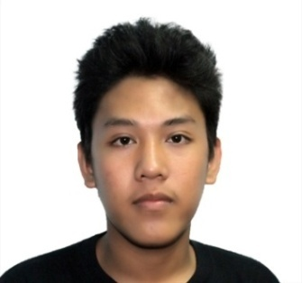

**JOBERT L. DELLAVA**

**Purok Saranay, San Pablo, Tacurong City**

**Sultan Kudarat**

**0905-093-4295**

**Personal Information**

**Date of Birth: November 3, 1996**

**Age: 20**

**Place of Birth: Koronadal, South Cotabato**

**Nationality: Filipino**

**Gender: Male**

**Civil Status: Single**

**Person to be contacted in case of emergency: Rona L. Dellava**

**Address: Purok Saranay, San Pablo, Tacurong City**

**Contact Number: (0926-219-6335)**

**Educational Background**

**College: Notre Dame of Tacurong College**

**Secondary: Tacurong Siloam ABC Learning Center Inc.**

**Elementary: Tacurong Pilot Elementary School**

**AFFILIATIONS**

**Philippine Society of Information Technology Students (PSITS),**

**Member -2013-2018**

**Philippine Society of Information Technology Students (PSITS),**

**Auditor -2015-2016**

**Student Personnel Assistant (SPA), member -2013-2017**

**Junior Ecologist Movement (JEM), member -2017-2018**

**APPENDIX J**

**Source Code**

**MAIN FORM**

#missing animation. menu. input name. database. keyboard

import pygame

from pygame.locals import *

Import cv2

import numpy as np

import sys

import argparse

import os

Import random

pygame.HWSURFACE

this set the start up position of the game

os.environ['SDL_VIDEO_WINDOW_POS'] = "%d,%d" % (150,50)

device = cv2.VideoCapture(0)

device.set(3, 1280.)#width

device.set(4, 720.)#height

WINDOWWIDTH = 1280

WINDOWHEIGHT = 720

FPS = 60

score = 0

multiplier = 1

name = ""

pygame.init()

pygame.mixer.init()

pygame.display.set_caption("Thesis 1: Fruit razor")

screen= pygame.display.set_mode([WINDOWWIDTH,WINDOWHEIGHT],pygame.FULLSCREEN)

xlocation = random.randint(40,700)

counter = 0

pointerx = 0

pointery = 0

gotTime = False

endGame = True

life = 5

speed = 20

starttime = 0

endtime = 0

isentername = 0

RED = pygame.Color(255,0,0)

BLUE = pygame.Color(0,0,255)

WHITE = pygame.Color(255,255,255)

BLACK = pygame.Color(0,0,0)

GREEN = pygame.Color(0, 255, 0)

screenstatus = 0

lasttimeout = 0

# set up assets folders

game_folder = os.path.dirname(__file__) #D:\Python

# concats the two folder

img_folder = os.path.join(game_folder,"img") #D:\Python\img

snd_folder = os.path.join(game_folder,'snd') #D:\Python\snd

class GameOver(pygame.sprite.Sprite):

#sprite of the Game over

def __init__(self, image_file, location):

pygame.sprite.Sprite.__init__(self) #call Sprite initializer

self.image = pygame.image.load(image_file)

self.rect = self.image.get_rect()

self.rect.left, self.rect.top = location

class QuitGame(pygame.sprite.Sprite):

#sprite of the Game over

def __init__(self, image_file, location):

pygame.sprite.Sprite.__init__(self) #call Sprite initializer

self.image = pygame.image.load(image_file)

self.rect = self.image.get_rect()

self.rect.left, self.rect.top = location

class AboutScreen(pygame.sprite.Sprite):

#sprite of the Game over

def __init__(self, image_file, location):

pygame.sprite.Sprite.__init__(self) #call Sprite initializer

self.image = pygame.image.load(image_file)

self.rect = self.image.get_rect()

self.rect.left, self.rect.top = location

class HelpScreen(pygame.sprite.Sprite):

#sprite of the Game over

def __init__(self, image_file, location):

pygame.sprite.Sprite.__init__(self) #call Sprite initializer

self.image = pygame.image.load(image_file)

self.rect = self.image.get_rect()

self.rect.left, self.rect.top = location

class MainMenu(pygame.sprite.Sprite):

#sprite of the Game over

def __init__(self, image_file, location):

pygame.sprite.Sprite.__init__(self) #call Sprite initializer

self.image = pygame.image.load(image_file)

self.rect = self.image.get_rect()

self.rect.left, self.rect.top = location

class ScoreMenu(pygame.sprite.Sprite):

#sprite of the Game over

def __init__(self, image_file, location):

pygame.sprite.Sprite.__init__(self) #call Sprite initializer

self.image = pygame.image.load(image_file)

self.rect = self.image.get_rect()

self.rect.left, self.rect.top = location

class DoYouWantToAgainPlayBackground(pygame.sprite.Sprite)

def __init__(self, image_file, location):

pygame.sprite.Sprite.__init__(self) #call Sprite initializer

self.image = pygame.image.load(image_file)

self.rect = self.image.get_rect()

self.rect.left, self.rect.top = location

class YesButtonQuit(pygame.sprite.Sprite):

#sprite of the Game over

def __init__(self):

pygame.sprite.Sprite.__init__(self)

self.image = pygame.image.load(os.path.join(img_folder, "yes-button.png")).convert_alpha()

self.rect = self.image.get_rect()

self.radius = int((self.rect.width * 0.5) / 2)

self.mask = pygame.mask.from_surface(self.image)

self.rect.x = 400

self.rect.y = 490

class NoButtonQuit(pygame.sprite.Sprite):

#sprite of the Game over

def __init__(self):

pygame.sprite.Sprite.__init__(self)

self.image = pygame.image.load(os.path.join(img_folder, "no-button.png")).convert_alpha()

self.rect = self.image.get_rect()

self.radius = int((self.rect.width * 0.5) / 2)

self.mask = pygame.mask.from_surface(self.image)

self.rect.x = 690

self.rect.y = 490

class YesButtonQuitTry(pygame.sprite.Sprite):

#sprite of the Game over

def __init__(self):

pygame.sprite.Sprite.__init__(self)

self.image = pygame.image.load(os.path.join(img_folder, "yes-button.png")).convert_alpha()

self.rect = self.image.get_rect()

self.radius = int((self.rect.width * 0.5) / 2)

self.mask = pygame.mask.from_surface(self.image)

self.rect.x = 234

self.rect.y = 301

class NoButtonQuitTry(pygame.sprite.Sprite):

#sprite of the Game over

def __init__(self):

pygame.sprite.Sprite.__init__(self)

self.image = pygame.image.load(os.path.join(img_folder, "no-button.png")).convert_alpha()

self.rect = self.image.get_rect()

self.radius = int((self.rect.width * 0.5) / 2)

self.mask = pygame.mask.from_surface(self.image)

self.rect.x = 906

self.rect.y = 301

class BackButtonScore(pygame.sprite.Sprite):

#sprite of the back button

def __init__(self):

pygame.sprite.Sprite.__init__(self)

self.image = pygame.image.load(os.path.join(img_folder, "back-button.png")).convert_alpha()

self.rect = self.image.get_rect()

self.radius = int((self.rect.width * 0.5) / 2)

self.mask = pygame.mask.from_surface(self.image)

self.rect.x = 16

self.rect.y = 152

class BackButtonAbout(pygame.sprite.Sprite):

#sprite of the back button

def __init__(self):

pygame.sprite.Sprite.__init__(self)

self.image = pygame.image.load(os.path.join(img_folder, "back-button.png")).convert_alpha()

self.rect = self.image.get_rect()

self.radius = int((self.rect.width * 0.3) / 2)

self.mask = pygame.mask.from_surface(self.image)

self.rect.x = 16

self.rect.y = 152

class BackButtonHelp(pygame.sprite.Sprite):

#sprite of the back button

def __init__(self):

pygame.sprite.Sprite.__init__(self)

self.image = pygame.image.load(os.path.join(img_folder, "back-button.png")).convert_alpha()

self.rect = self.image.get_rect()

self.radius = int((self.rect.width * 0.3) / 2)

self.mask = pygame.mask.from_surface(self.image)

self.rect.x = 16

self.rect.y = 152

class PlayButton(pygame.sprite.Sprite):

#sprite of the Game over

def __init__(self):

pygame.sprite.Sprite.__init__(self)

self.image = pygame.image.load(os.path.join(img_folder, "play-button.png")).convert_alpha()

self.rect = self.image.get_rect()

self.radius = int((self.rect.width * 0.3) / 2)

self.mask = pygame.mask.from_surface(self.image)

self.rect.x = 513

self.rect.y = 290

class ScoreButton(pygame.sprite.Sprite):

#sprite of the Game over

def __init__(self):

pygame.sprite.Sprite.__init__(self)

self.image = pygame.image.load(os.path.join(img_folder, "score-button.png")).convert_alpha()

self.rect = self.image.get_rect()

self.radius = int((self.rect.width * 0.3) / 2)

self.mask = pygame.mask.from_surface(self.image)

self.rect.x = 513

self.rect.y = 380

class HelpButton(pygame.sprite.Sprite):

#sprite of the Game over

def __init__(self):

pygame.sprite.Sprite.__init__(self)

self.image = pygame.image.load(os.path.join(img_folder, "help-button.png")).convert_alpha()

self.rect = self.image.get_rect()

self.radius = int((self.rect.width * 0.3) / 2)

self.mask = pygame.mask.from_surface(self.image)

self.rect.x = 513

self.rect.y = 460

class AboutButton(pygame.sprite.Sprite):

#sprite of the Game over

def __init__(self):

pygame.sprite.Sprite.__init__(self)

self.image = pygame.image.load(os.path.join(img_folder, "about-button.png")).convert_alpha()

self.rect = self.image.get_rect()

self.radius = int((self.rect.width * 0.3) / 2)

self.mask = pygame.mask.from_surface(self.image)

self.rect.x = 513

self.rect.y = 560

class ExitButton(pygame.sprite.Sprite):

#sprite of the Game over

def __init__(self):

pygame.sprite.Sprite.__init__(self)

self.image = pygame.image.load(os.path.join(img_folder, "exit-button.png")).convert_alpha()

self.rect = self.image.get_rect()

self.radius = int((self.rect.width * 0.3) / 2)

self.mask = pygame.mask.from_surface(self.image)

self.rect.x = 1032

self.rect.y = 14

class Time1(pygame.sprite.Sprite):

#sprite of the heart1

def __init__(self, image_file, location):

pygame.sprite.Sprite.__init__(self) #call Sprite initializer

self.image = pygame.image.load(image_file)

self.rect = self.image.get_rect()

self.rect.left, self.rect.top = location

class Time2(pygame.sprite.Sprite):

#sprite of the heart1

def __init__(self, image_file, location):

pygame.sprite.Sprite.__init__(self) #call Sprite initializer

self.image = pygame.image.load(image_file)

self.rect = self.image.get_rect()

self.rect.left, self.rect.top = location

class Time3(pygame.sprite.Sprite):

#sprite of the heart1

def __init__(self, image_file, location):

pygame.sprite.Sprite.__init__(self) #call Sprite initializer

self.image = pygame.image.load(image_file)

self.rect = self.image.get_rect()

self.rect.left, self.rect.top = location

class Time4(pygame.sprite.Sprite):

#sprite of the heart1

def __init__(self, image_file, location):

pygame.sprite.Sprite.__init__(self) #call Sprite initializer

self.image = pygame.image.load(image_file)

self.rect = self.image.get_rect()

self.rect.left, self.rect.top = location

class Time5(pygame.sprite.Sprite):

#sprite of the heart1

def __init__(self, image_file, location):

pygame.sprite.Sprite.__init__(self) #call Sprite initializer

self.image = pygame.image.load(image_file)

self.rect = self.image.get_rect()

self.rect.left, self.rect.top = location

class Time6(pygame.sprite.Sprite):

#sprite of the heart1

def __init__(self, image_file, location):

pygame.sprite.Sprite.__init__(self) #call Sprite initializer

self.image = pygame.image.load(image_file)

self.rect = self.image.get_rect()

self.rect.left, self.rect.top = location

class Time7(pygame.sprite.Sprite):

#sprite of the heart1

def __init__(self, image_file, location):

pygame.sprite.Sprite.__init__(self) #call Sprite initializer

self.image = pygame.image.load(image_file)

self.rect = self.image.get_rect()

self.rect.left, self.rect.top = location

class Time8(pygame.sprite.Sprite):

#sprite of the heart1

def __init__(self, image_file, location):

pygame.sprite.Sprite.__init__(self) #call Sprite initializer

self.image = pygame.image.load(image_file)

self.rect = self.image.get_rect()

self.rect.left, self.rect.top = location

class Time9(pygame.sprite.Sprite):

#sprite of the heart1

def __init__(self, image_file, location):

pygame.sprite.Sprite.__init__(self) #call Sprite initializer

self.image = pygame.image.load(image_file)

self.rect = self.image.get_rect()

self.rect.left, self.rect.top = location

class Time10(pygame.sprite.Sprite):

#sprite of the heart1

def __init__(self, image_file, location):

pygame.sprite.Sprite.__init__(self) #call Sprite initializer

self.image = pygame.image.load(image_file)

self.rect = self.image.get_rect()

self.rect.left, self.rect.top = location

class Heart1(pygame.sprite.Sprite):

#sprite of the heart1

def __init__(self, image_file, location):

pygame.sprite.Sprite.__init__(self) #call Sprite initializer

self.image = pygame.image.load(image_file)

self.rect = self.image.get_rect()

self.rect.left, self.rect.top = location

class Heart2(pygame.sprite.Sprite):

#sprite of the heart2

def __init__(self, image_file, location):

pygame.sprite.Sprite.__init__(self) #call Sprite initializer

self.image = pygame.image.load(image_file)

self.rect = self.image.get_rect()

self.rect.left, self.rect.top = location

class Heart3(pygame.sprite.Sprite):

#sprite of the heart3

def __init__(self, image_file, location):

pygame.sprite.Sprite.__init__(self) #call Sprite initializer

self.image = pygame.image.load(image_file)

self.rect = self.image.get_rect()

self.rect.left, self.rect.top = location

class Heart4(pygame.sprite.Sprite):

#sprite of the heart4

def __init__(self, image_file, location):

pygame.sprite.Sprite.__init__(self) #call Sprite initializer

self.image = pygame.image.load(image_file)

self.rect = self.image.get_rect()

self.rect.left, self.rect.top = location

class Heart5(pygame.sprite.Sprite):

#sprite of the heart5

def __init__(self, image_file, location):

pygame.sprite.Sprite.__init__(self) #call Sprite initializer

self.image = pygame.image.load(image_file)

self.rect = self.image.get_rect()

self.rect.left, self.rect.top = location

class MainGameFrame(pygame.sprite.Sprite):

#sprite of the background in game proper

def __init__(self, image_file, location):

pygame.sprite.Sprite.__init__(self) #call Sprite initializer

self.image = pygame.image.load(image_file)

self.rect = self.image.get_rect()

self.rect.left, self.rect.top = location

class Player(pygame.sprite.Sprite):

#sprite for the Player

def __init__(self):

pygame.sprite.Sprite.__init__(self)

self.image = pygame.image.load(os.path.join(img_folder, "sword.png")).convert_alpha()

self.rect = self.image.get_rect()

self.radius = int((self.rect.width * 0.5) / 2)

self.mask = pygame.mask.from_surface(self.image)

class Pomelo(pygame.sprite.Sprite):

#sprite for the Pomelo

def __init__(self):

pygame.sprite.Sprite.__init__(self)

self.image=pygame.image.load(os.path.join(img_folder, "pomelo.png")).convert_alpha()

self.image_orig=pygame.image.load(os.path.join(img_folder, "pomelo.png")).convert_alpha()

self.rect = self.image.get_rect()

self.radius = int((self.rect.width * 1) / 2)

self.rect.x = random.randrange(60, WINDOWWIDTH - (self.rect.width+59))

self.rect.y = random.randrange(0, 20)

self.speedy = random.randrange(8, 15)

self.rot = 0

self.rot_speed = random.randrange(-8,8)

self.last_update = pygame.time.get_ticks()

def rotate(self):

now = pygame.time.get_ticks()

if now - self.last_update > 50:

self.last_update = now

self.rot = (self.rot + self.rot_speed) % 360

new_image = pygame.transform.rotate(self.image_orig, self.rot)

old_center = self.rect.center

self.image = new_image

self.rect = self.image.get_rect()

self.rect.center = old_center

def update(self):

self.rotate()

self.rect.y += self.speedy

#when this fruit reaches the bottom. kill this

if self.rect.top > WINDOWHEIGHT - 20:

global life

life -= 1

self.kill()

class Mangosteen(pygame.sprite.Sprite):

#sprite for the mangosteen

def __init__(self):

pygame.sprite.Sprite.__init__(self)

self.image=pygame.image.load(os.path.join(img_folder, "mangosteen.png")).convert_alpha()

self.image_orig=pygame.image.load(os.path.join(img_folder, "mangosteen.png")).convert_alpha()

self.rect = self.image.get_rect()

self.radius = int((self.rect.width * 1) / 2)

self.rect.x = random.randrange(60, WINDOWWIDTH - (self.rect.width+59))

self.rect.y = random.randrange(0, 20)

self.speedy = random.randrange(8, 15)

self.rot = 0

self.rot_speed = random.randrange(-8,8)

self.last_update = pygame.time.get_ticks()

def rotate(self):

now = pygame.time.get_ticks()

if now - self.last_update > 50:

self.last_update = now

self.rot = (self.rot + self.rot_speed) % 360

new_image = pygame.transform.rotate(self.image_orig, self.rot)

old_center = self.rect.center

self.image = new_image

self.rect = self.image.get_rect()

self.rect.center = old_center

def update(self):

self.rotate()

self.rect.y += self.speedy

#when this fruit reaches the bottom. kill this

if self.rect.top > WINDOWHEIGHT - 20:

global life

life -= 1

self.kill()

class Papaya(pygame.sprite.Sprite):

#sprite for the Papaya

def __init__(self):

pygame.sprite.Sprite.__init__(self)

self.image=pygame.image.load(os.path.join(img_folder, "papaya.png")).convert_alpha()

self.image_orig=pygame.image.load(os.path.join(img_folder, "papaya.png")).convert_alpha()

self.rect = self.image.get_rect()

self.radius = int((self.rect.width * 1) / 2)

self.rect.x = random.randrange(60, WINDOWWIDTH - (self.rect.width+59))

self.rect.y = random.randrange(0, 20)

self.speedy = random.randrange(8, 15)

self.rot = 0

self.rot_speed = random.randrange(-8,8)

self.last_update = pygame.time.get_ticks()

def rotate(self):

now = pygame.time.get_ticks()

if now - self.last_update > 50:

self.last_update = now

self.rot = (self.rot + self.rot_speed) % 360

new_image = pygame.transform.rotate(self.image_orig, self.rot)

old_center = self.rect.center

self.image = new_image

self.rect = self.image.get_rect()

self.rect.center = old_center

def update(self):

self.rotate()

self.rect.y += self.speedy

#when this fruit reaches the bottom. kill this

if self.rect.top > WINDOWHEIGHT - 20:

global life

life -= 1

self.kill()

class Atis(pygame.sprite.Sprite):

#sprite for the Atis

def __init__(self):

pygame.sprite.Sprite.__init__(self)

self.image=pygame.image.load(os.path.join(img_folder, "atis.png")).convert_alpha()

self.image_orig=pygame.image.load(os.path.join(img_folder, "atis.png")).convert_alpha()

self.rect = self.image.get_rect()

self.radius = int((self.rect.width * 1) / 2)

self.rect.x = random.randrange(60, WINDOWWIDTH - (self.rect.width+59))

self.rect.y = random.randrange(0, 20)

self.speedy = random.randrange(8, 15)

self.rot = 0

self.rot_speed = random.randrange(-8,8)

self.last_update = pygame.time.get_ticks()

def rotate(self):

now = pygame.time.get_ticks()

if now - self.last_update > 50:

self.last_update = now

self.rot = (self.rot + self.rot_speed) % 360

new_image = pygame.transform.rotate(self.image_orig, self.rot)

old_center = self.rect.center

self.image = new_image

self.rect = self.image.get_rect()

self.rect.center = old_center

def update(self):

self.rotate()

self.rect.y += self.speedy

if self.rect.top > WINDOWHEIGHT - 20:

global life

life -= 1

self.kill()

class Mango(pygame.sprite.Sprite):

#sprite for the Mango

def __init__(self):

pygame.sprite.Sprite.__init__(self)

self.image = pygame.image.load(os.path.join(img_folder, "mangonm3.png")).convert_alpha()

self.image_orig = pygame.image.load(os.path.join(img_folder, "mangonm3.png")).convert_alpha()

self.rect = self.image.get_rect()

self.radius = int((self.rect.width * 1) / 2)

self.rect.x = random.randrange(60, WINDOWWIDTH - (self.rect.width+59))

self.rect.y = random.randrange(0, 20)

self.speedy = random.randrange(8, 15)

self.rot = 0

self.rot_speed = random.randrange(-8,8)

self.last_update = pygame.time.get_ticks()

def rotate(self):

now = pygame.time.get_ticks()

if now - self.last_update > 50:

self.last_update = now

self.rot = (self.rot + self.rot_speed) % 360

new_image = pygame.transform.rotate(self.image_orig, self.rot)

old_center = self.rect.center

self.image = new_image

self.rect = self.image.get_rect()

self.rect.center = old_center

def update(self):

self.rotate()

self.rect.y += self.speedy

#when this fruit reaches the bottom. kill this

if self.rect.top > WINDOWHEIGHT - 20:

self.kill()

class Durian(pygame.sprite.Sprite):

#sprite for the Durian

def __init__(self):

pygame.sprite.Sprite.__init__(self)

self.image = pygame.image.load(os.path.join(img_folder, "duriannm0.png")).convert_alpha()

self.image_orig = pygame.image.load(os.path.join(img_folder, "duriannm0.png")).convert_alpha()

self.rect = self.image.get_rect()

self.radius = int((self.rect.width * 1) / 2)

self.rect.x = random.randrange(60, WINDOWWIDTH - (self.rect.width+59))

self.rect.y = random.randrange(0, 20)

self.speedy = random.randrange(8, 15)

self.rot = 0

self.rot_speed = random.randrange(-8,8)

self.last_update = pygame.time.get_ticks()

def rotate(self):

now = pygame.time.get_ticks()

if now - self.last_update > 50:

self.last_update = now

self.rot = (self.rot + self.rot_speed) % 360

new_image = pygame.transform.rotate(self.image_orig, self.rot)

old_center = self.rect.center

self.image = new_image

self.rect = self.image.get_rect()

self.rect.center = old_center

def update(self):

self.rotate()

self.rect.y += self.speedy

if self.rect.top > WINDOWHEIGHT - 20:

self.kill()

class Bomb(pygame.sprite.Sprite):

#sprite for the Bomb

def __init__(self):

pygame.sprite.Sprite.__init__(self)

self.image = pygame.image.load(os.path.join(img_folder, "bomb.png")).convert_alpha()

self.image_orig = pygame.image.load(os.path.join(img_folder, "bomb.png")).convert_alpha()

self.rect = self.image.get_rect()

self.radius = int((self.rect.width * 1) / 2)

self.rect.x = random.randrange(60, WINDOWWIDTH - (self.rect.width+59))

self.rect.y = random.randrange(0, 20)

self.speedy = random.randrange(8, 15)

self.rot = 0

self.rot_speed = random.randrange(-8,8)

self.last_update = pygame.time.get_ticks()

def rotate(self):

now = pygame.time.get_ticks()

if now - self.last_update > 50:

self.last_update = now

self.rot = (self.rot + self.rot_speed) % 360

new_image = pygame.transform.rotate(self.image_orig, self.rot)

old_center = self.rect.center

self.image = new_image

self.rect = self.image.get_rect()

self.rect.center = old_center

def update(self):

self.rotate()

self.rect.y += self.speedy

if self.rect.top > WINDOWHEIGHT - 20:

self.kill()

class atisSlice(pygame.sprite.Sprite):

def __init__(self, center, size):

pygame.sprite.Sprite.__init__(self)

self.size = size

self.image = atis_slice_animation[self.size][0]

self.rect = self.image.get_rect()

self.rect.center = center

self.frame = 0

self.last_update = pygame.time.get_ticks()

self.frame_rate = 50

def update(self):

now = pygame.time.get_ticks()

if now - self.last_update > self.frame_rate:

self.last_update = now

self.frame += 1

if self.frame == len(atis_slice_animation[self.size]):

self.kill()

else:

center = self.rect.center

self.image = atis_slice_animation[self.size][self.frame]

self.rect = self.image.get_rect()

self.rect.center = center

class atisx2Slice(pygame.sprite.Sprite):

def __init__(self, center, size):

pygame.sprite.Sprite.__init__(self)

self.size = size

self.image = atisx2_slice_animation[self.size][0]

self.rect = self.image.get_rect()

self.rect.center = center

self.frame = 0

self.last_update = pygame.time.get_ticks()

self.frame_rate = 50

def update(self):

now = pygame.time.get_ticks()

if now - self.last_update > self.frame_rate:

self.last_update = now

self.frame += 1

if self.frame == len(atisx2_slice_animation[self.size]):

self.kill()

else:

center = self.rect.center

self.image = atisx2_slice_animation[self.size][self.frame]

self.rect = self.image.get_rect()

self.rect.center = center

class durianSlice(pygame.sprite.Sprite):

def __init__(self, center, size):

pygame.sprite.Sprite.__init__(self)

self.size = size

self.image = durian_slice_animation[self.size][0]

self.rect = self.image.get_rect()

self.rect.center = center

self.frame = 0

self.last_update = pygame.time.get_ticks()

self.frame_rate = 50

def update(self):

now = pygame.time.get_ticks()

if now - self.last_update > self.frame_rate:

self.last_update = now

self.frame += 1

if self.frame == len(durian_slice_animation[self.size]):

self.kill()

else:

center = self.rect.center

self.image = durian_slice_animation[self.size][self.frame]

self.rect = self.image.get_rect()

self.rect.center = center

class durianx2Slice(pygame.sprite.Sprite):

def __init__(self, center, size):

pygame.sprite.Sprite.__init__(self)

self.size = size

self.image = durianx2_slice_animation[self.size][0]

self.rect = self.image.get_rect()

self.rect.center = center

self.frame = 0

self.last_update = pygame.time.get_ticks()

self.frame_rate = 50

def update(self):

now = pygame.time.get_ticks()

if now - self.last_update > self.frame_rate:

self.last_update = now

self.frame += 1

if self.frame == len(durianx2_slice_animation[self.size]):

self.kill()

else:

center = self.rect.center

self.image = durianx2_slice_animation[self.size][self.frame]

self.rect = self.image.get_rect()

self.rect.center = center

class mangoSlice(pygame.sprite.Sprite):

def __init__(self, center, size):

pygame.sprite.Sprite.__init__(self)

self.size = size

self.image = mango_slice_animation[self.size][0]

self.rect = self.image.get_rect()

self.rect.center = center

self.frame = 0

self.last_update = pygame.time.get_ticks()

self.frame_rate = 50

def update(self):

now = pygame.time.get_ticks()

if now - self.last_update > self.frame_rate:

self.last_update = now

self.frame += 1

if self.frame == len(mango_slice_animation[self.size]):

self.kill()

else:

center = self.rect.center

self.image = mango_slice_animation[self.size][self.frame]

self.rect = self.image.get_rect()

self.rect.center = center

class mangox2Slice(pygame.sprite.Sprite):

def __init__(self, center, size):

pygame.sprite.Sprite.__init__(self)

self.size = size

self.image = mangox2_slice_animation[self.size][0]

self.rect = self.image.get_rect()

self.rect.center = center

self.frame = 0

self.last_update = pygame.time.get_ticks()

self.frame_rate = 50

def update(self):

now = pygame.time.get_ticks()

if now - self.last_update > self.frame_rate:

self.last_update = now

self.frame += 1

if self.frame == len(mangox2_slice_animation[self.size]):

self.kill()

else:

center = self.rect.center

self.image = mangox2_slice_animation[self.size][self.frame]

self.rect = self.image.get_rect()

self.rect.center = center

class mangosteenSlice(pygame.sprite.Sprite):

def __init__(self, center, size):

pygame.sprite.Sprite.__init__(self)

self.size = size

self.image = mangosteen_slice_animation[self.size][0]

self.rect = self.image.get_rect()

self.rect.center = center

self.frame = 0

self.last_update = pygame.time.get_ticks()

self.frame_rate = 50

def update(self):

now = pygame.time.get_ticks()

if now - self.last_update > self.frame_rate:

self.last_update = now

self.frame += 1

if self.frame == len(mangosteen_slice_animation[self.size]):

self.kill()

else:

center = self.rect.center

self.image = mangosteen_slice_animation[self.size][self.frame]

self.rect = self.image.get_rect()

self.rect.center = center

class mangosteenx2Slice(pygame.sprite.Sprite):

def __init__(self, center, size):

pygame.sprite.Sprite.__init__(self)

self.size = size

self.image = mangosteenx2_slice_animation[self.size][0]

self.rect = self.image.get_rect()

self.rect.center = center

self.frame = 0

self.last_update = pygame.time.get_ticks()

self.frame_rate = 50

def update(self):

now = pygame.time.get_ticks()

if now - self.last_update > self.frame_rate:

self.last_update = now

self.frame += 1

if self.frame == len(mangosteenx2_slice_animation[self.size]):

self.kill()

else:

center = self.rect.center

self.image = mangosteenx2_slice_animation[self.size][self.frame]

self.rect = self.image.get_rect()

self.rect.center = center

class papayaSlice(pygame.sprite.Sprite):

def __init__(self, center, size):

pygame.sprite.Sprite.__init__(self)

self.size = size

self.image = papaya_slice_animation[self.size][0]

self.rect = self.image.get_rect()

self.rect.center = center

self.frame = 0

self.last_update = pygame.time.get_ticks()

self.frame_rate = 50

def update(self):

now = pygame.time.get_ticks()

if now - self.last_update > self.frame_rate:

self.last_update = now

self.frame += 1

if self.frame == len(papaya_slice_animation[self.size]):

self.kill()

else:

center = self.rect.center

self.image = papaya_slice_animation[self.size][self.frame]

self.rect = self.image.get_rect()

self.rect.center = center

class papayax2Slice(pygame.sprite.Sprite):

def __init__(self, center, size):

pygame.sprite.Sprite.__init__(self)

self.size = size

self.image = papayax2_slice_animation[self.size][0]

self.rect = self.image.get_rect()

self.rect.center = center

self.frame = 0

self.last_update = pygame.time.get_ticks()

self.frame_rate = 50

def update(self):

now = pygame.time.get_ticks()

if now - self.last_update > self.frame_rate:

self.last_update = now

self.frame += 1

if self.frame == len(papayax2_slice_animation[self.size]):

self.kill()

else:

center = self.rect.center

self.image = papayax2_slice_animation[self.size][self.frame]

self.rect = self.image.get_rect()

self.rect.center = center

class pomeloSlice(pygame.sprite.Sprite):

def __init__(self, center, size):

pygame.sprite.Sprite.__init__(self)

self.size = size

self.image = pomelo_slice_animation[self.size][0]

self.rect = self.image.get_rect()

self.rect.center = center

self.frame = 0

self.last_update = pygame.time.get_ticks()

self.frame_rate = 50

def update(self):

now = pygame.time.get_ticks()

if now - self.last_update > self.frame_rate:

self.last_update = now

self.frame += 1

if self.frame == len(pomelo_slice_animation[self.size]):

self.kill()

else:

center = self.rect.center

self.image = pomelo_slice_animation[self.size][self.frame]

self.rect = self.image.get_rect()

self.rect.center = center

class pomelox2Slice(pygame.sprite.Sprite):

def __init__(self, center, size):

pygame.sprite.Sprite.__init__(self)

self.size = size

self.image = pomelox2_slice_animation[self.size][0]

self.rect = self.image.get_rect()

self.rect.center = center

self.frame = 0

self.last_update = pygame.time.get_ticks()

self.frame_rate = 50

def update(self):

now = pygame.time.get_ticks()

if now - self.last_update > self.frame_rate:

self.last_update = now

self.frame += 1

if self.frame == len(pomelox2_slice_animation[self.size]):

self.kill()

else:

center = self.rect.center

self.image = pomelox2_slice_animation[self.size][self.frame]

self.rect = self.image.get_rect()

self.rect.center = center

class SubmitButton(pygame.sprite.Sprite):

#sprite of the Game over

def __init__(self):

pygame.sprite.Sprite.__init__(self)

self.image = pygame.image.load(os.path.join(img_folder, "submit-button.png")).convert_alpha()

self.rect = self.image.get_rect()

self.radius = int((self.rect.width * 0.5) / 2)

self.mask = pygame.mask.from_surface(self.image)

self.rect.x = 414

self.rect.y = 503

slice_sound = pygame.mixer.Sound(os.path.join(snd_folder, "slice.wav"))

bomb_sound = pygame.mixer.Sound(os.path.join(snd_folder, "bomb.wav"))

pygame.mixer.music.load(os.path.join(snd_folder, "background.wav"))

pygame.mixer.music.set_volume(0.2)

all_sprites = pygame.sprite.Group()

player = Player()

all_sprites.add(player)

all_sprites.update()

Time1 = Time1(os.path.join(img_folder, "1.png"), [50,65])

Time2 = Time2(os.path.join(img_folder, "2.png"), [50,65])

Time3 = Time3(os.path.join(img_folder, "3.png"), [50,65])

Time4 = Time4(os.path.join(img_folder, "4.png"), [50,65])

Time5 = Time5(os.path.join(img_folder, "5.png"), [50,65])

Time6 = Time6(os.path.join(img_folder, "6.png"), [50,65])

Time7 = Time7(os.path.join(img_folder, "7.png"), [50,65])

Time8 = Time8(os.path.join(img_folder, "8.png"), [50,65])

Time9 = Time9(os.path.join(img_folder, "9.png"), [50,65])

Time10 = Time10(os.path.join(img_folder, "10.png"), [50,65])

#call Heart1 function

Heart1 = Heart1(os.path.join(img_folder, "heart.png"), [100,15])

Heart2 = Heart2(os.path.join(img_folder, "heart.png"), [130,15])

Heart3 = Heart3(os.path.join(img_folder, "heart.png"), [160,15])

Heart4 = Heart4(os.path.join(img_folder, "heart.png"), [190,15])

Heart5 = Heart5(os.path.join(img_folder, "heart.png"), [220,15])

GameOver = GameOver(os.path.join(img_folder, "gameover.png"), [0,0])

MainMenu = MainMenu(os.path.join(img_folder, "main-menu-background.png"), [0,0])

MainGameFrame = MainGameFrame(os.path.join(img_folder, "frame.png"), [0,0])

QuitGame = QuitGame(os.path.join(img_folder, "quit-background.png"), [0,0])

ScoreMenu = ScoreMenu(os.path.join(img_folder, "score-background.png"), [0,0])

AboutScreen = AboutScreen(os.path.join(img_folder, "about-background.png"), [0,0])

HelpScreen = HelpScreen(os.path.join(img_folder, "help-background.png"), [0,0])

DoYouWantToAgainPlayBackground = DoYouWantToAgainPlayBackground(os.path.join(img_folder, "youwanttoplayagain-background.png"), [0,0])

atis_slice_animation = {}

atis_slice_animation['nm'] = []

for i in range(4):

filename = 'atis-slashnm{}.png'.format(i)

img = pygame.image.load(os.path.join(img_folder, filename)).convert_alpha()

atis_slice_animation['nm'].append(img)

atisx2_slice_animation = {}

atisx2_slice_animation['nm'] = []

for i in range(4):

filename = 'atisx2-slashnm{}.png'.format(i)

img = pygame.image.load(os.path.join(img_folder, filename)).convert_alpha()

atisx2_slice_animation['nm'].append(img)

durian_slice_animation = {}

durian_slice_animation['nm'] = []

for i in range(4):

filename = 'durian-slashnm{}.png'.format(i)

img = pygame.image.load(os.path.join(img_folder, filename)).convert_alpha()

durian_slice_animation['nm'].append(img)

mango_slice_animation = {}

mango_slice_animation['nm'] = []

for i in range(4):

filename = 'mango-slashnm{}.png'.format(i)

img = pygame.image.load(os.path.join(img_folder, filename)).convert_alpha()

mango_slice_animation['nm'].append(img)

mangox2_slice_animation = {}

mangox2_slice_animation['nm'] = []

for i in range(4):

filename = 'mangox2-slashnm{}.png'.format(i)

img = pygame.image.load(os.path.join(img_folder, filename)).convert_alpha()

mangox2_slice_animation['nm'].append(img)

mangosteen_slice_animation = {}

mangosteen_slice_animation['nm'] = []

for i in range(4):

filename = 'mangosteen-slashnm{}.png'.format(i)

img = pygame.image.load(os.path.join(img_folder, filename)).convert_alpha()

mangosteen_slice_animation['nm'].append(img)

mangosteenx2_slice_animation = {}

mangosteenx2_slice_animation['nm'] = []

for i in range(4):

filename = 'mangosteenx2-slashnm{}.png'.format(i)

img = pygame.image.load(os.path.join(img_folder, filename)).convert_alpha()

mangosteenx2_slice_animation['nm'].append(img)

papaya_slice_animation = {}

papaya_slice_animation['nm'] = []

for i in range(4):

filename = 'papaya-slashnm{}.png'.format(i)

img = pygame.image.load(os.path.join(img_folder, filename)).convert_alpha()

papaya_slice_animation['nm'].append(img)

papayax2_slice_animation = {}

papayax2_slice_animation['nm'] = []

for i in range(4):

filename = 'papayax2-slashnm{}.png'.format(i)

img = pygame.image.load(os.path.join(img_folder, filename)).convert_alpha()

papayax2_slice_animation['nm'].append(img)

pomelo_slice_animation = {}

pomelo_slice_animation['nm'] = []

for i in range(4):

filename = 'pomelo-slashnm{}.png'.format(i)

img = pygame.image.load(os.path.join(img_folder, filename)).convert_alpha()

pomelo_slice_animation['nm'].append(img)

pomelox2_slice_animation = {}

pomelox2_slice_animation['nm'] = []

for i in range(4):

filename = 'pomelox2-slashnm{}.png'.format(i)

img = pygame.image.load(os.path.join(img_folder, filename)).convert_alpha()

pomelox2_slice_animation['nm'].append(img)

durian_drop_animation = {}

durian_drop_animation['nm'] = []

for i in range(4):

filename = 'duriannm{}.png'.format(i)

img = pygame.image.load(os.path.join(img_folder, filename)).convert_alpha()

durian_drop_animation['nm'].append(img)

mango_drop_animation = {}

mango_drop_animation['nm'] = []

for i in range(4):

if multiplier == 1:

filename = 'mango-slashnm{}.png'.format(i)

if multiplier == 2:

filename = 'mangox2-slashnm{}.png'.format(i)

img = pygame.image.load(os.path.join(img_folder, filename)).convert_alpha()

mango_drop_animation['nm'].append(img)

pomeloes = pygame.sprite.Group()

mangosteens = pygame.sprite.Group()

papayas = pygame.sprite.Group()

mangoes = pygame.sprite.Group()

durians = pygame.sprite.Group()

bombs = pygame.sprite.Group()

atises = pygame.sprite.Group()

all_sprites = pygame.sprite.Group()

yesButtonQuits = pygame.sprite.Group()

noButtonQuits = pygame.sprite.Group()

PlayButtons = pygame.sprite.Group()

HelpButtons = pygame.sprite.Group()

ScoreButtons = pygame.sprite.Group()

AboutButtons = pygame.sprite.Group()

ExitButtons = pygame.sprite.Group()

#FPS controller

fpsController = pygame.time.Clock()

pygame.mixer.music.play(loops=-1)

pygame.mixer.music.pause()

#game loop

try:

while endGame:

#codes for the keyboard

#process input events

for event in pygame.event.get():

if event.type == KEYUP:

if event.key == K_ESCAPE:

sys.exit(0)

fpsController.tick(FPS)

ret, frame = device.read()

# 65 28 45

# 93 150 126

hsv = cv2.cvtColor(frame, cv2.COLOR_BGR2HSV)

lower_range = np.array([42, 70, 110])

upper_range = np.array([79,255,255])

mask = cv2.inRange(hsv, lower_range, upper_range)

_, contours, _= cv2.findContours(mask, cv2.RETR_EXTERNAL, cv2.CHAIN_APPROX_SIMPLE)

#contours, hierarchy = cv2.findContours(mask, cv2.RETR_EXTERNAL, cv2.CHAIN_APPROX_SIMPLE)

maximumArea = 0

bestContour = None

for contour in contours:

currentArea = cv2.contourArea(contour)

if currentArea > maximumArea:

bestContour = contour

maximumArea = currentArea

if bestContour is not None:

(x,y),radius = cv2.minEnclosingCircle(bestContour)

center = (int(x),int(y))

radius = int(radius)

mouse_x, mouse_y = (abs(center[0] - 1280),center[1])

circlecoor = 'x: %s y: %s'%(abs(center[0] - 1280),center[1])

#print("The value of x: %s and the value of y: %s" %(x,y))

pointerx = circlecoor

pointery = radius

#the cursor

player.rect.center = (abs(center[0] - 1280),center[1])

else:

player.rect.x = (WINDOWWIDTH)

all_sprites.draw(screen)

all_sprites.update()

if screenstatus == 0: #0 for main menu

#main menu

counter = 0

currenttime = 0

speed = 25

name = ""

isentername = 0

screen.blit(MainMenu.image, MainMenu.rect)

pomeloes = pygame.sprite.Group()

mangosteens = pygame.sprite.Group()

papayas = pygame.sprite.Group()

mangoes = pygame.sprite.Group()

durians = pygame.sprite.Group()

bombs = pygame.sprite.Group()

atises = pygame.sprite.Group()

all_sprites = pygame.sprite.Group()

yesButtonQuits = pygame.sprite.Group()

noButtonQuits = pygame.sprite.Group()

PlayButtons = pygame.sprite.Group()

HelpButtons = pygame.sprite.Group()

ScoreButtons = pygame.sprite.Group()

AboutButtons = pygame.sprite.Group()

ExitButtons = pygame.sprite.Group()

playButton = PlayButton()

all_sprites.add(playButton)

PlayButtons.add(playButton)

scoreButton = ScoreButton()

all_sprites.add(scoreButton)

ScoreButtons.add(scoreButton)

helpButton = HelpButton()

all_sprites.add(helpButton)

HelpButtons.add(helpButton)

aboutButton = AboutButton()

all_sprites.add(aboutButton)

AboutButtons.add(aboutButton)

exitButton = ExitButton()

all_sprites.add(exitButton)

ExitButtons.add(exitButton)

slices = pygame.sprite.spritecollide(player, PlayButtons, False, pygame.sprite.collide_circle)

for slice in slices:

screenstatus = 1

lasttimeout = currenttime

pomeloes = pygame.sprite.Group()

mangosteens = pygame.sprite.Group()

papayas = pygame.sprite.Group()

mangoes = pygame.sprite.Group()

durians = pygame.sprite.Group()

bombs = pygame.sprite.Group()

atises = pygame.sprite.Group()

all_sprites = pygame.sprite.Group()

yesButtonQuits = pygame.sprite.Group()

noButtonQuits = pygame.sprite.Group()

PlayButtons = pygame.sprite.Group()

HelpButtons = pygame.sprite.Group()

ScoreButtons = pygame.sprite.Group()

AboutButtons = pygame.sprite.Group()

ExitButtons = pygame.sprite.Group()

slices=pygame.sprite.spritecollide(player, ScoreButtons, False, pygame.sprite.collide_circle)

for slice in slices:

screenstatus = 2

slices=pygame.sprite.spritecollide(player, HelpButtons, False, pygame.sprite.collide_circle)

for slice in slices:

screenstatus = 3

slices=pygame.sprite.spritecollide(player, AboutButtons, False, pygame.sprite.collide_circle)

for slice in slices:

screenstatus = 6

slices=pygame.sprite.spritecollide(player, ExitButtons, False, pygame.sprite.collide_circle)

for slice in slices:

screenstatus = 4

all_sprites.draw(screen)

all_sprites.update()

if screenstatus == 1: #1 for main game

#start code for main game

#start music

currenttime = int(pygame.time.get_ticks()/1000) - lasttimeout

pygame.mixer.music.unpause()

#codes for the durian x2 effect.

if currenttime >= starttime and currenttime <= endtime:

multiplier = 2

else:

multiplier = 1

starttime = 0

endtime = 0

counter = counter + 1

#adjust the drop speed of the fruits

if currenttime >= 1:

speed = 27

if currenttime >= 15:

speed = 24

if currenttime >= 45:

speed = 20

if currenttime >= 80:

speed = 18

if (life > 0) and (counter % speed == 0):

#when game is not yet over, drop fruits

#randomize number from 1 to 4

randomNumber = random.randrange(1, 5)

#randomNumber = 4

if randomNumber == 1:

papaya = Papaya()

papayas.add(papaya)

all_sprites.add(papaya)

if randomNumber == 2:

mangosteen = Mangosteen()

all_sprites.add(mangosteen)

mangosteens.add(mangosteen)

if randomNumber == 3:

pomelo = Pomelo()

all_sprites.add(pomelo)

pomeloes.add(pomelo)

if randomNumber == 4:

atis = Atis()

all_sprites.add(atis)

atises.add(atis)

#30 percent chance to drop the bomb in every second

#randomize number from 1 to 10

randomDropBombChance = random.randrange(1, 11)

if randomDropBombChance == 1 or randomDropBombChance == 2 or randomDropBombChance == 3:

bomb = Bomb()

all_sprites.add(bomb)

bombs.add(bomb)

#20 percent chance to drop the mango in every second

#randomize number from 1 to 10

randomDropMangoChance = random.randrange(1, 11)

if randomDropMangoChance == 1 or randomDropMangoChance == 2:

mango = Mango()

all_sprites.add(mango)

mangoes.add(mango)

randomDropDurianChance = random.randrange(1, 11)

if randomDropDurianChance == 1 and (starttime == 0 and endtime == 0):

durian = Durian()

all_sprites.add(durian)

durians.add(durian)

slices = pygame.sprite.spritecollide(player, papayas, True, pygame.sprite.collide_circle)

for slice in slices:

if (life > 0):

slice_sound.play()

score += (1 * multiplier)

if multiplier == 1:

slicepapaya = papayaSlice(slice.rect.center, 'nm')

if multiplier == 2:

slicepapaya = papayax2Slice(slice.rect.center, 'nm')

all_sprites.add(slicepapaya)

slices = pygame.sprite.spritecollide(player, mangosteens, True, pygame.sprite.collide_circle)

for slice in slices:

if (life > 0):

slice_sound.play()

score += (1 * multiplier)

if multiplier == 1:

slicemangosteen = mangosteenSlice(slice.rect.center, 'nm')

if multiplier == 2:

slicemangosteen = mangosteenx2Slice(slice.rect.center, 'nm')

all_sprites.add(slicemangosteen)

slices = pygame.sprite.spritecollide(player, pomeloes, True, pygame.sprite.collide_circle)

for slice in slices:

if (life > 0):

slice_sound.play()

score += (1 * multiplier)

if multiplier == 1:

slicepomelo= pomeloSlice(slice.rect.center, 'nm')

if multiplier == 2:

slicepomelo= pomelox2Slice(slice.rect.center, 'nm')

all_sprites.add(slicepomelo)

slices = pygame.sprite.spritecollide(player, atises, True, pygame.sprite.collide_circle)

for slice in slices:

if (life > 0):

slice_sound.play()

score += (1 * multiplier)

if multiplier == 1:

sliceatis = atisSlice(slice.rect.center, 'nm')

if multiplier == 2:

sliceatis = atisx2Slice(slice.rect.center, 'nm')

all_sprites.add(sliceatis)

slices = pygame.sprite.spritecollide(player, durians, True, pygame.sprite.collide_circle)

for slice in slices:

if (life > 0):

slice_sound.play()

starttime = currenttime

endtime = currenttime + 10

slicedurian = durianSlice(slice.rect.center, 'nm')

all_sprites.add(slicedurian)

slices = pygame.sprite.spritecollide(player, mangoes, True, pygame.sprite.collide_circle)

for slice in slices:

if (life > 0):

slice_sound.play()

score += (5 * multiplier)

if multiplier == 1:

slicemango = mangoSlice(slice.rect.center, 'nm')

if multiplier == 2:

slicemango = mangox2Slice(slice.rect.center, 'nm')

all_sprites.add(slicemango)

slices = pygame.sprite.spritecollide(player, bombs, True, pygame.sprite.collide_circle)

for slice in slices:

if (life > 0):

bomb_sound.play()

pygame.mixer.music.pause()

life = 0

myFont = pygame.font.SysFont('Agent Orange', 25)

myFont2 = pygame.font.SysFont('Agent Orange', 35)

myFont3 = pygame.font.SysFont('Agent Orange', 37)

if life == 0:

screenstatus = 5

lasttimeout = currenttime

screen.blit(MainGameFrame.image, MainGameFrame.rect

if life > 0:

#life label

GOsurf = myFont.render('Life', True, WHITE)

GOrect = GOsurf.get_rect()

GOrect.midtop = (60, 15)

screen.blit(GOsurf,GOrect)

# #time label

# GOsurf = myFont2.render('%s'%currenttime, True, WHITE)

# GOrect = GOsurf.get_rect()

# GOrect.midtop = (640, 10)

# screen.blit(GOsurf,GOrect)

#score label

GOsurf = myFont.render('Score: ', True, WHITE)

GOrect = GOsurf.get_rect()

GOrect.midtop = (1060, 15)

screen.blit(GOsurf,GOrect)

GOsurf = myFont3.render('%s'%score, True, GREEN)

GOrect = GOsurf.get_rect()

GOrect.midtop = (1210, 10)

screen.blit(GOsurf,GOrect)

if multiplier == 2:

if endtime - currenttime == 10:

screen.blit(Time10.image, Time10.rect)

if endtime - currenttime == 9:

screen.blit(Time9.image, Time9.rect)

if endtime - currenttime == 8:

screen.blit(Time8.image, Time8.rect)

if endtime - currenttime == 7:

screen.blit(Time7.image, Time7.rect)

if endtime - currenttime == 6:

screen.blit(Time6.image, Time6.rect)

if endtime - currenttime == 5:

screen.blit(Time5.image, Time5.rect)

if endtime - currenttime == 4:

screen.blit(Time4.image, Time4.rect)

if endtime - currenttime == 3:

screen.blit(Time3.image, Time3.rect)

if endtime - currenttime == 2:

screen.blit(Time2.image, Time2.rect)

if endtime - currenttime == 1:

screen.blit(Time1.image, Time1.rect)

if life == 5:

screen.blit(Heart5.image, Heart5.rect)

if life >= 4:

screen.blit(Heart4.image, Heart4.rect)

if life >= 3:

screen.blit(Heart3.image, Heart3.rect)

if life >= 2:

screen.blit(Heart2.image, Heart2.rect)

if life >= 1:

screen.blit(Heart1.image, Heart1.rect)

#end code for main game

if screenstatus == 2: #2 for score screen

#codes

screen.blit(ScoreMenu.image, ScoreMenu.rect)

pomeloes = pygame.sprite.Group()

mangosteens = pygame.sprite.Group()

papayas = pygame.sprite.Group()

mangoes = pygame.sprite.Group()

durians = pygame.sprite.Group()

bombs = pygame.sprite.Group()

atises = pygame.sprite.Group()

all_sprites = pygame.sprite.Group()

yesButtonQuits = pygame.sprite.Group()

noButtonQuits = pygame.sprite.Group()

PlayButtons = pygame.sprite.Group()

HelpButtons = pygame.sprite.Group()

ScoreButtons = pygame.sprite.Group()

AboutButtons = pygame.sprite.Group()

ExitButtons = pygame.sprite.Group()

ExitButtons = pygame.sprite.Group()

BackButtonScores = pygame.sprite.Group()

backButtonScore = BackButtonScore()

all_sprites.add(backButtonScore)

BackButtonScores.add(backButtonScore)

SubmitButtons = pygame.sprite.Group()

DeleteButtons = pygame.sprite.Group()

slices = pygame.sprite.spritecollide(player, BackButtonScores, False, pygame.sprite.collide_circle)

for slice in slices:

screenstatus = 0

scoresfrom = []

with open("scores.txt") as f:

for line in f:

namex, scorex = line.split(',')

scorex = int(scorex)

scoresfrom.append((namex, scorex))

scoresfrom.sort(key=lambda s: s[1])

length = len(scoresfrom)

if length >= 4:

first = scoresfrom[length-1]

second = scoresfrom[length-2]

third = scoresfrom[length-3]

if length == 3:

first = scoresfrom[length-1]

second = scoresfrom[length-2]

third = ""

if length == 2:

first = scoresfrom[length-1]

second = ""

third = ""

if length == 1 or line == "":

first = ""

second = ""

third = ""

print(first)

print(second)

print(third)

scoreFontStyle = pygame.font.SysFont('Agent Orange', 25)

GOsurf = scoreFontStyle.render("Top Three Highest Scores", True, WHITE)

GOrect = GOsurf.get_rect()

GOrect.midtop = (619, 175)

screen.blit(GOsurf,GOrect)

scoreFontStyle = pygame.font.SysFont('Agent Orange', 25)

GOsurf = scoreFontStyle.render("%s %s" %(first[0], first[1]), True, WHITE)

GOrect = GOsurf.get_rect()

GOrect.midtop = (619, 245)

screen.blit(GOsurf,GOrect)

scoreFontStyle = pygame.font.SysFont('Agent Orange', 25)

GOsurf = scoreFontStyle.render("%s %s" %(second[0], second[1]), True, WHITE)

GOrect = GOsurf.get_rect()

GOrect.midtop = (619, 346)

screen.blit(GOsurf,GOrect)

scoreFontStyle = pygame.font.SysFont('Agent Orange', 25)

GOsurf = scoreFontStyle.render("%s %s" %(third[0], third[1]), True, WHITE)

GOrect = GOsurf.get_rect()

GOrect.midtop = (619, 447)

screen.blit(GOsurf,GOrect)

all_sprites.draw(screen)

all_sprites.update()

if screenstatus == 3: #6 for about

screen.blit(HelpScreen.image, HelpScreen.rect)

pomeloes = pygame.sprite.Group()

mangosteens = pygame.sprite.Group()

papayas = pygame.sprite.Group()

mangoes = pygame.sprite.Group()

durians = pygame.sprite.Group()

bombs = pygame.sprite.Group()

atises = pygame.sprite.Group()

all_sprites = pygame.sprite.Group()

yesButtonQuits = pygame.sprite.Group()

noButtonQuits = pygame.sprite.Group()

PlayButtons = pygame.sprite.Group()

HelpButtons = pygame.sprite.Group()

ScoreButtons = pygame.sprite.Group()

AboutButtons = pygame.sprite.Group()

ExitButtons = pygame.sprite.Group()

backButtonHelps = pygame.sprite.Group()

helpButtonAbout = BackButtonHelp()

all_sprites.add(helpButtonAbout)

backButtonHelps.add(helpButtonAbout)

slices=pygame.sprite.spritecollide(player, backButtonHelps, False, pygame.sprite.collide_circle)

for slice in slices:

screenstatus = 0

all_sprites.draw(screen)

all_sprites.update()

if screenstatus == 4: #quit Game

screen.blit(QuitGame.image, QuitGame.rect)

pomeloes = pygame.sprite.Group()

mangosteens = pygame.sprite.Group()

papayas = pygame.sprite.Group()

mangoes = pygame.sprite.Group()

durians = pygame.sprite.Group()

bombs = pygame.sprite.Group()

atises = pygame.sprite.Group()

all_sprites = pygame.sprite.Group()

yesButtonQuits = pygame.sprite.Group()

noButtonQuits = pygame.sprite.Group()

PlayButtons = pygame.sprite.Group()

HelpButtons = pygame.sprite.Group()

ScoreButtons = pygame.sprite.Group()

AboutButtons = pygame.sprite.Group()

ExitButtons = pygame.sprite.Group()

yesButtonQuit = YesButtonQuit()

all_sprites.add(yesButtonQuit)

yesButtonQuits.add(yesButtonQuit)

noButtonQuit = NoButtonQuit()

all_sprites.add(noButtonQuit)

noButtonQuits.add(noButtonQuit)

slices=pygame.sprite.spritecollide(player, yesButtonQuits, False, pygame.sprite.collide_circle)

for slice in slices:

endGame = False

slices = pygame.sprite.spritecollide(player, noButtonQuits, False, pygame.sprite.collide_circle)

for slice in slices:

screenstatus = 0

all_sprites.draw(screen)

all_sprites.update()

if screenstatus == 5: #5 for game over

counter = 0

currenttime = 0

speed = 25

if isentername == 1:

with open("scores.txt", "a") as text_file:

text_file.write("%s, %s\n" % (name, score))

screenstatus = 7

pomeloes = pygame.sprite.Group()

mangosteens = pygame.sprite.Group()

papayas = pygame.sprite.Group()

mangoes = pygame.sprite.Group()

durians = pygame.sprite.Group()

bombs = pygame.sprite.Group()

atises = pygame.sprite.Group()

all_sprites = pygame.sprite.Group()

yesButtonQuits = pygame.sprite.Group()

noButtonQuits = pygame.sprite.Group()

PlayButtons = pygame.sprite.Group()

HelpButtons = pygame.sprite.Group()

ScoreButtons = pygame.sprite.Group()

AboutButtons = pygame.sprite.Group()

ExitButtons = pygame.sprite.Group()

SubmitButtons = pygame.sprite.Group()

screen.blit(GameOver.image, GameOver.rect)

starttime = 0

endtime = 0

pygame.mixer.music.pause()

if name != "":

submitButton = SubmitButton()

all_sprites.add(submitButton)

SubmitButtons.add(submitButton)

for event in pygame.event.get():

if event.type == KEYUP:

if len(name) < 10:

if event.key == K_a:

name += 'A'

if event.key == K_b:

name += 'B'

if event.key == K_c:

name += 'C'

if event.key == K_d:

name += 'D'

if event.key == K_e:

name += 'E'

if event.key == K_f:

name += 'F'

if event.key == K_g:

name += 'G'

if event.key == K_h:

name += 'H'

if event.key == K_i:

name += 'I'

if event.key == K_j:

name += 'J'

if event.key == K_k:

name += 'K'

if event.key == K_l:

name += 'L'

if event.key == K_m:

name += 'M'

if event.key == K_n:

name += 'N'

if event.key == K_o:

name += 'O'

if event.key == K_p:

name += 'P'

if event.key == K_q:

name += 'Q'

if event.key == K_r:

name += 'R'

if event.key == K_s:

name += 'S'

if event.key == K_t:

name += 'T'

if event.key == K_u:

name += 'U'

if event.key == K_v:

name += 'V'

if event.key == K_w:

name += 'W'

if event.key == K_x:

name += 'X'

if event.key == K_y:

name += 'Y'

if event.key == K_z:

name += 'Z'

if event.key == K_SPACE:

name += ' '

if event.key == K_BACKSPACE:

name = name[:-1]

slices = pygame.sprite.spritecollide(player, SubmitButtons, True, pygame.sprite.collide_circle)

for slice in slices:

with open("scores.txt", "a") as text_file:

text_file.write("%s, %s\n" % (name, score))

screenstatus = 7

isentername = 1

if gotTime == False:

finalTime = currenttime

gotTime = True

myFont1 = pygame.font.SysFont('Agent Orange', 40)

myFontScoreandTime = pygame.font.SysFont('Agent Orange', 55)

GOsurf = myFont1.render('SCORE:', True, BLACK)

GOrect = GOsurf.get_rect()

GOrect.midtop = (395, 250)

screen.blit(GOsurf,GOrect)

GOsurf = myFontScoreandTime.render('%s'%score, True, GREEN)

GOrect = GOsurf.get_rect()

GOrect.midtop = (590, 240)

screen.blit(GOsurf,GOrect)

GOsurf = myFont1.render('%s'%name, True, RED)

GOrect = GOsurf.get_rect()

GOrect.midtop = (490, 410)

screen.blit(GOsurf,GOrect)

all_sprites.draw(screen)

all_sprites.update()

if screenstatus == 6: #6 for about

screen.blit(AboutScreen.image, AboutScreen.rect)

pomeloes = pygame.sprite.Group()

mangosteens = pygame.sprite.Group()

papayas = pygame.sprite.Group()

mangoes = pygame.sprite.Group()

durians = pygame.sprite.Group()

bombs = pygame.sprite.Group()

atises = pygame.sprite.Group()

all_sprites = pygame.sprite.Group()

yesButtonQuits = pygame.sprite.Group()

noButtonQuits = pygame.sprite.Group()

PlayButtons = pygame.sprite.Group()

HelpButtons = pygame.sprite.Group()

ScoreButtons = pygame.sprite.Group()

AboutButtons = pygame.sprite.Group()

ExitButtons = pygame.sprite.Group()

backButtonAbouts = pygame.sprite.Group()

backButtonAbout = BackButtonAbout()

all_sprites.add(backButtonAbout)

backButtonAbouts.add(backButtonAbout)

slices=pygame.sprite.spritecollide(player, backButtonAbouts, False, pygame.sprite.collide_circle)

for slice in slices:

screenstatus = 0

all_sprites.draw(screen)

all_sprites.update()

if screenstatus == 7: #7 for do you want to play again

counter = 0

currenttime = 0

speed = 25

screen.blit(DoYouWantToAgainPlayBackground.image, DoYouWantToAgainPlayBackground.rect)

pomeloes = pygame.sprite.Group()

mangosteens = pygame.sprite.Group()

papayas = pygame.sprite.Group()

mangoes = pygame.sprite.Group()

durians = pygame.sprite.Group()

bombs = pygame.sprite.Group()

atises = pygame.sprite.Group()

all_sprites = pygame.sprite.Group()

YesButtonQuitTrys = pygame.sprite.Group()

noButtonQuitsTrys = pygame.sprite.Group()

PlayButtons = pygame.sprite.Group()

HelpButtons = pygame.sprite.Group()

ScoreButtons = pygame.sprite.Group()

AboutButtons = pygame.sprite.Group()

ExitButtons = pygame.sprite.Group()

noButtonQuitTrys = pygame.sprite.Group()

YesButtonQuitTrys = pygame.sprite.Group()

noButtonQuitTry = NoButtonQuitTry()

all_sprites.add(noButtonQuitTry)

noButtonQuitTrys.add(noButtonQuitTry)

yesButtonQuitTry = YesButtonQuitTry()

all_sprites.add(yesButtonQuitTry)

YesButtonQuitTrys.add(yesButtonQuitTry)

slices = pygame.sprite.spritecollide(player, YesButtonQuitTrys, False, pygame.sprite.collide_circle)

for slice in slices:

pomeloes = pygame.sprite.Group()

mangosteens = pygame.sprite.Group()

papayas = pygame.sprite.Group()

mangoes = pygame.sprite.Group()

durians = pygame.sprite.Group()

bombs = pygame.sprite.Group()

atises = pygame.sprite.Group()

all_sprites = pygame.sprite.Group()

YesButtonQuitTrys = pygame.sprite.Group()

noButtonQuitsTrys = pygame.sprite.Group()

PlayButtons = pygame.sprite.Group()

HelpButtons = pygame.sprite.Group()

ScoreButtons = pygame.sprite.Group()

AboutButtons = pygame.sprite.Group()

ExitButtons = pygame.sprite.Group()

noButtonQuitTrys = pygame.sprite.Group()

YesButtonQuitTrys = pygame.sprite.Group()

score = 0

life = 5

lasttimeout = currenttime

screenstatus = 1

slices=pygame.sprite.spritecollide(player, noButtonQuitTrys, False, pygame.sprite.collide_circle)

for slice in slices:

pomeloes = pygame.sprite.Group()

mangosteens = pygame.sprite.Group()

papayas = pygame.sprite.Group()

mangoes = pygame.sprite.Group()

durians = pygame.sprite.Group()

bombs = pygame.sprite.Group()

atises = pygame.sprite.Group()

all_sprites = pygame.sprite.Group()

YesButtonQuitTrys = pygame.sprite.Group()

noButtonQuitsTrys = pygame.sprite.Group()

PlayButtons = pygame.sprite.Group()

HelpButtons = pygame.sprite.Group()

ScoreButtons = pygame.sprite.Group()

AboutButtons = pygame.sprite.Group()

ExitButtons = pygame.sprite.Group()

noButtonQuitTrys = pygame.sprite.Group()

YesButtonQuitTrys = pygame.sprite.Group()

screenstatus = 0

score = 0

name = ""

life = 5

all_sprites.draw(screen)

all_sprites.update()

screen.blit(player.image, player.rect)

pygame.display.flip()

frame = np.rot90(frame,1)

frame = cv2.cvtColor(frame, cv2.COLOR_BGR2RGB)

frame = pygame.surfarray.make_surface(frame)

screen.blit(frame, (0,0))

except (KeyboardInterrupt, SystemExit):

pygame.quit()

device.release()

cv2.destroyAllWindows()